**Installing a Core i7 LGA 1366 Processor Safely**

We're going to assume you have an [Intel motherboard](http://www.pcstats.com/articleview.cfm?articleid=2385&page=2) and processor at hand, both still in their boxes. For this DIY Guide PCSTATS will be using an [Intel Core](http://www.pcstats.com/articleview.cfm?articleid=2385&page=2) i7 920 processor and an MSI Computer [X58 Platinum motherboard](http://www.msicomputer.com/product/p_spec.asp?model=X58_Platinum&class=mb) .

**Step 1:** Remove the [motherboard](http://www.pcstats.com/articleview.cfm?articleid=2385&page=2) from its box and protective packaging. Place the anti-static bag or foam mat under the motherboard to protect it, then lay the board down on a flat space like a table.

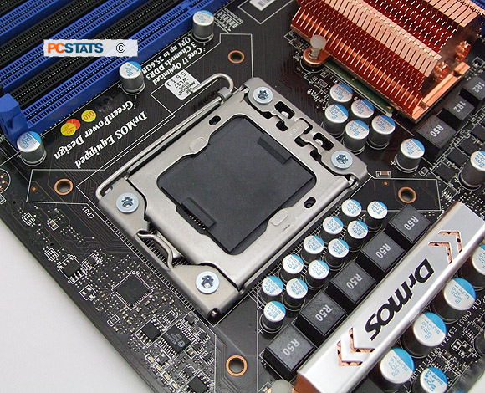

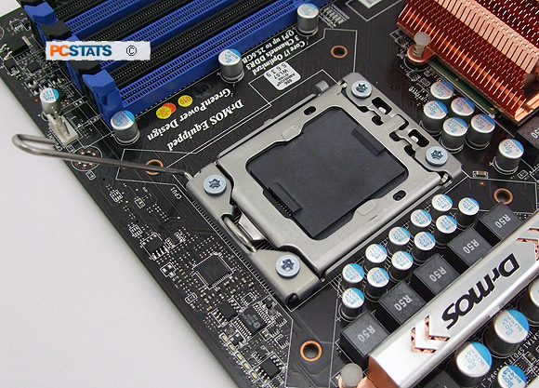

Using the small metal tab on the right edge of the load plate, push down to flip up the load plate to expose the protective cover and CPU socket.

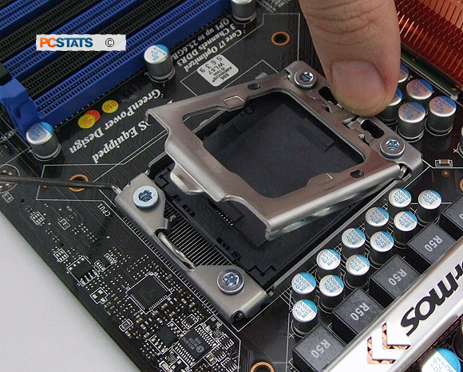

**Inserting the socket 1366 CPU the right way**

Remove the [Intel Core](http://www.pcstats.com/articleview.cfm?articleid=2385&page=3" \t "_top)

[http://konac.kontera.com/javascript/lib/imgs/grey_loader.gif](http://www.pcstats.com/articleview.cfm?articleid=2385&page=3" \t "_top)

i7 processor from its box and plastic clam shell packaging. To take off the protective black plastic chip carrier cover, hold the [processor](http://www.pcstats.com/articleview.cfm?articleid=2385&page=3) by its corners and release one of the plastic tabs. Be careful not to touch the contacts on the underside.

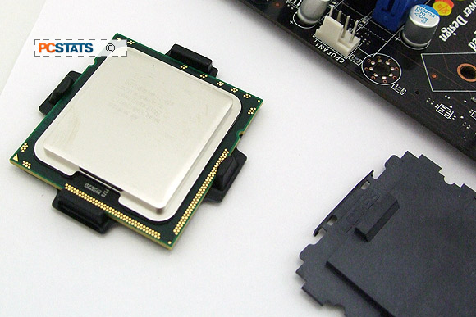

Now holding the processor by its sides or corners, look at the bottom. Check for any damage or foreign material on the contacts. Also note the two alignment notches on either side of the processor pictured below.

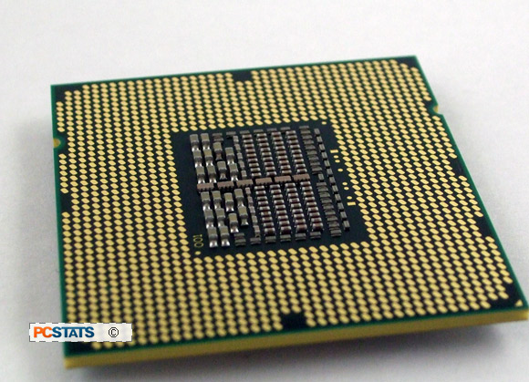

These fit into the pair of plastic extensions pictured below on the LGA1366 socket, ensuring that the processor is oriented correctly.

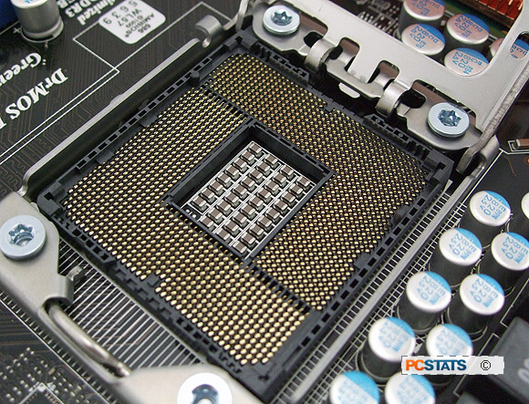

Holding the processor by its sides, orient it so that the two socket extensions will fit into the two notches on the processor. Lower the processor gently and vertically down into the socket, ensuring that it is lowered straight and sits evenly.

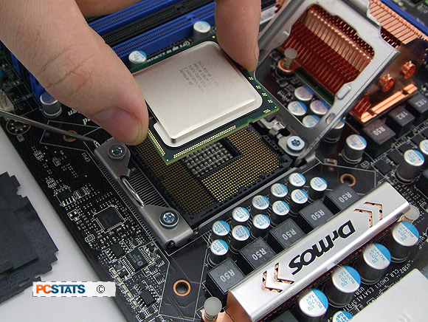

There are two gaps in the plastic wall of the socket that provide space for your fingers as you lower the chip, so use them. For illustration purposes the [Intel processor](http://www.pcstats.com/articleview.cfm?articleid=2385&page=3) is shown below with one of the tabs lined up. You should not install the CPU at an angle like this however.

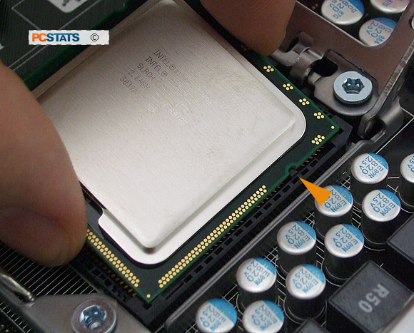

It's advisable not to drop the CPU into place, as that may damage the fragile contact pins.

**Locking the Processor in Position**

Note the two spaces in the socket frame in the image below, this is where your fingers should grip the [Intel processor](http://www.pcstats.com/articleview.cfm?articleid=2385&page=4). The space allows you to slowly and gently lower the CPU into the LGA775 socket. The CPU alignment notches are highlighted next to the orange arrows.

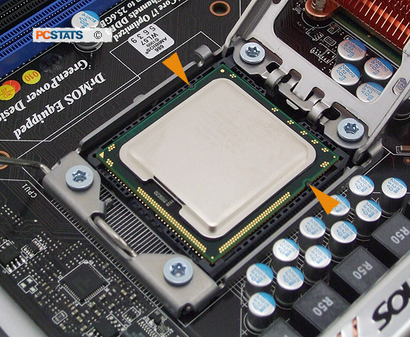

The Intel processor should sit flat in the LGA1366 socket, with the little gold triangle pointing towards the cam lever arm (lower left corner in the picture above). In the CPU is not flush in the socket, or the tabs are not aligned, remove and check the orientation once more.

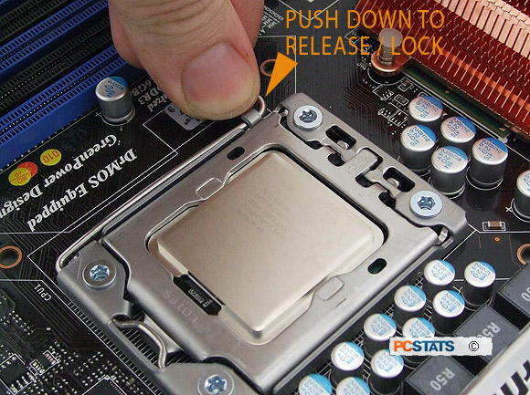

Securing the lever under the retention tab will fasten the load plate correctly. Your processor is now correctly in place and ready for [heatsink](http://www.pcstats.com/articleview.cfm?articleid=2385&page=4) installation. time to install the heatsink, this isn't complicated but can be a little tricky in the confines of a dark computer case.

**Installing the CPU Heatsink Correctly**

Place your computer case down flat with the motherboard and processor facing you. Remove the [heatsink](http://www.pcstats.com/articleview.cfm?articleid=2385&page=5) from the processor box and check the bottom to make sure that the thermal interface material on the bottom is undamaged. You don't need to add any additional thermal paste or other materials.

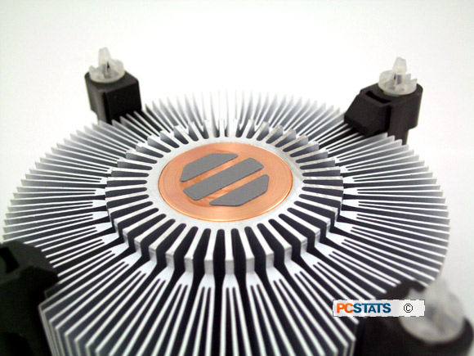

If the heatsink didn't come with any thermal compound applied, add a small amount to the top of the [Intel processor](http://www.pcstats.com/articleview.cfm?articleid=2385&page=5) and spread it around evenly. Never install a heatsink without thermal compound!

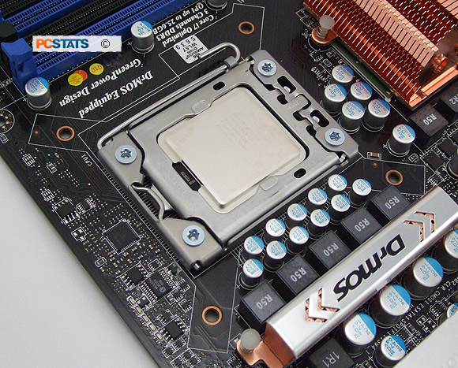

Note the four holes in the motherboard around the socket. These coincide with the 'legs' of your socket 1366 heatsink. Lower the heatsink vertically down onto the processor and socket so that each of the 'legs' lines up with a hole. There is no special way the heatsink has to face, as long as the point on the end of each of the 'legs' fits into one of the holes.

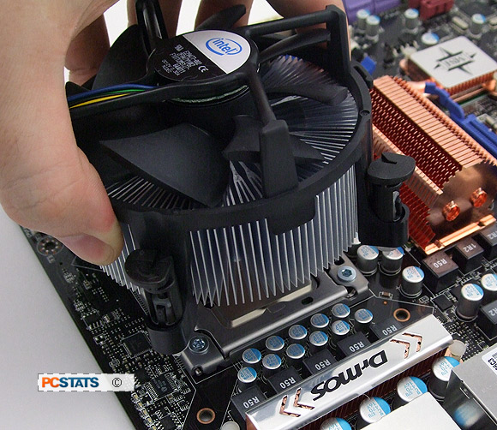

Ensure that the black top of each fastener is rotated into the correct locking orientation, with the arrow pointing away from the heatsink, and the groove in the top oriented towards the center of the heatsink as illustrated above. This orientation ensures the fastener will lock into place when pressed down.

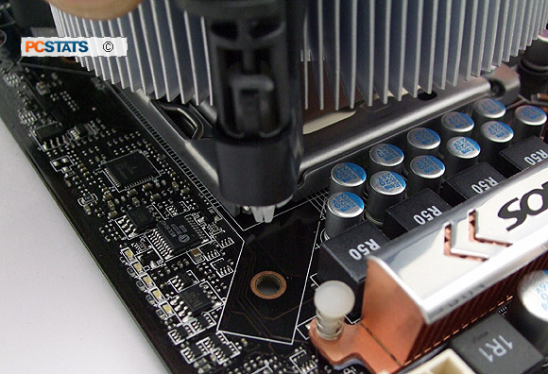

Once the heatsink is sitting on the processor with one fastener in each hole, hold it in place with one hand while pressing down firmly on each of the fastener 'legs' in turn. You should hear a loud click to indicate each clip has snapped into the locked position. Ensure that the heatsink is sitting evenly on top of the socket and processor.

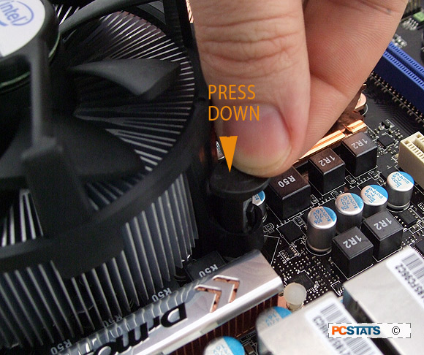

Now attach the fan [power cable](http://www.pcstats.com/articleview.cfm?articleid=2385&page=5) to the corresponding 4-pin or 3-pin connector on the motherboard.

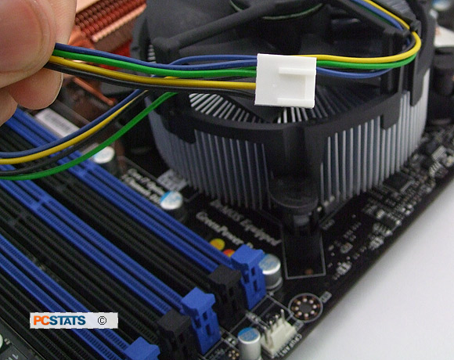

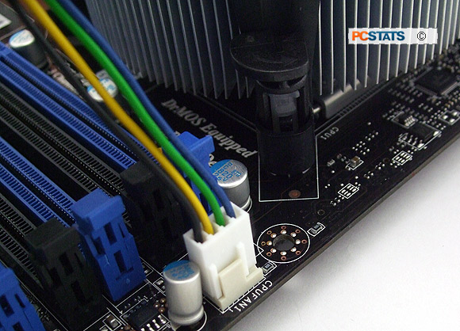

Consult your motherboard manual if you are unsure of the location. Ensure that the [cable](http://www.pcstats.com/articleview.cfm?articleid=2385&page=5) cannot become snagged in the fan blades. Your processor and heatsink are now installed correctly. Hook up the rest of your computer system and try it out!

If you need to remove or upgrade the Intel socket 1366 processor, that procedure is covered next. You'll need a flathead screwdriver for this, as well as the plastic protective covers for both the socket and the processor.

**Removing Socket 1366 heatsinks and processors safely**

Lay your computer case down flat so that the motherboard and [heatsink](http://www.pcstats.com/articleview.cfm?articleid=2385&page=6) are facing you.

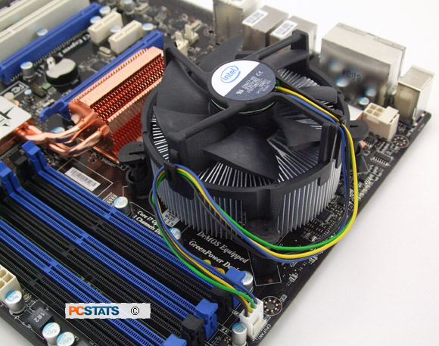

Using the flathead screwdriver, rotate the top of each of the fastener 'legs' of the heatsink 90 degrees counterclockwise. This will unlock the fasteners from the [motherboard](http://www.pcstats.com/articleview.cfm?articleid=2385&page=6). Now pull up on each leg to release it, then remove the heatsink from the motherboard by lifting it up vertically. A slight twisting motion may be necessary.

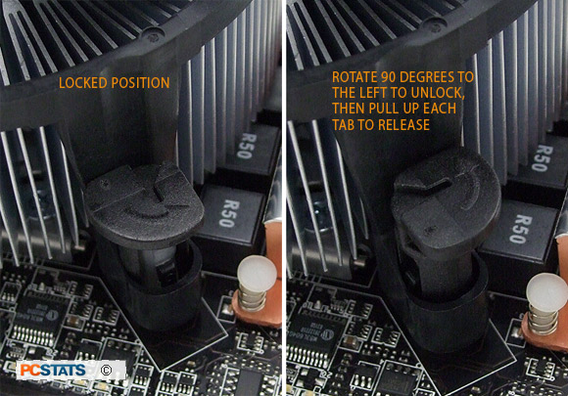

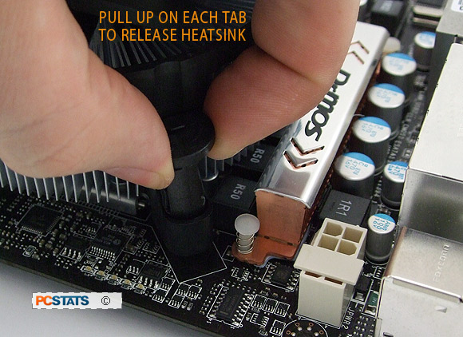

If you are planning to reuse the same heatsink, reset each of the fastener 'legs' by using your screwdriver to twist each one 90 degrees clockwise.

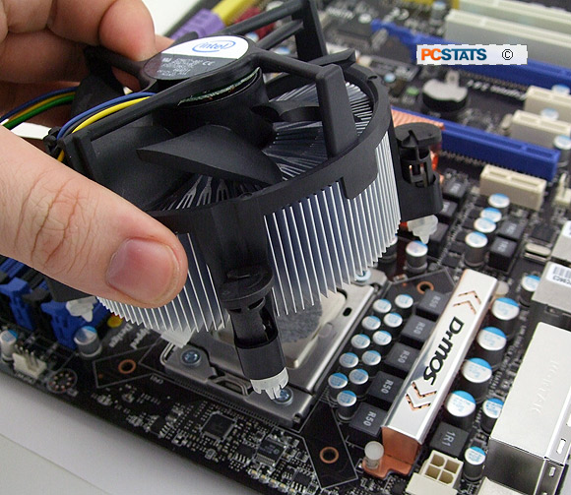

To remove the Intel socket 1366 [processor](http://www.pcstats.com/articleview.cfm?articleid=2385&page=6), first release the socket lever by pressing it down and away from the socket, then lift it up so that it hangs loose.

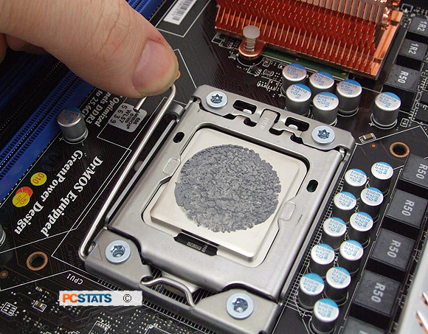

Using the metal tab at the back of the load plate, lift the load plate up gently to expose the processor.

Pick the processor up gently with your thumb and forefinger. There are two gaps in the plastic wall of the socket that correspond to each finger, making it easier to grasp the CPU (where the orange arrows are in the picture below).

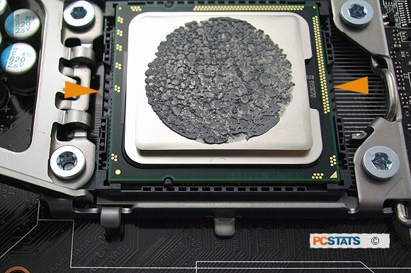

Lift the processor vertically out of the socket and place it back in its plastic protective cover.

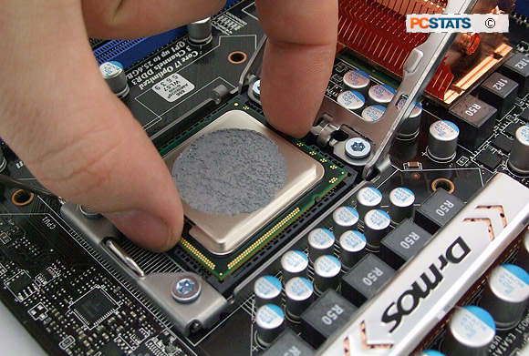

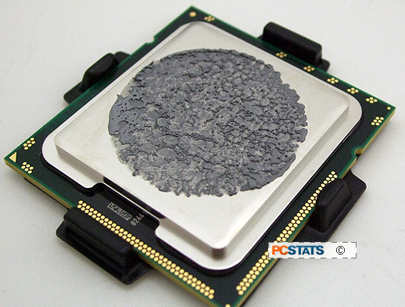

If you are not installing a new CPU, snap the plastic protective cover back over the socket and close the load plate. Then lock it back into place with the lever. You're done!

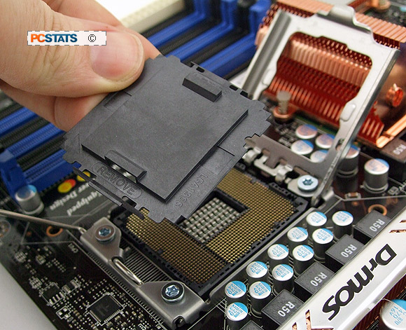

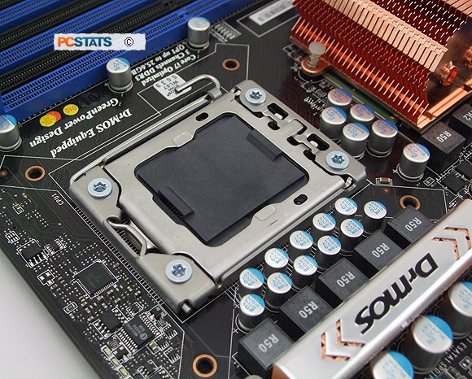

The steps outlined in this PCSTATS DIY Guide work for both [Intel socket](http://www.pcstats.com/articleview.cfm?articleid=2385&page=6) 1366 and Intel socket 1156 processors.